ROUND 2:

Q. Given root of a binary tree, return the right side view of the tree (from top to bottom)
Ex. 1 <-
2 3 <-
4 8 5 6 <-
Return [1,3,6]
struct Node {
Int val;
Node *left;
Node *right;
}

-------------------------------

Void print_right(Node *root, vector<int> &ans, int height)
{
if(root == NULL)
Return;
If (height == ans.size())
ans.push_back(root->val);
print_right(root->right, ans, height + 1);
print_right(root->left, ans, height + 1);
return;
}
vector<int> ans;
print_right(root, ans, 0);

Q. Given a graph (binary adjacency matrix) find the sinkhole in it. If no sinkhole exists return -1;
Sinkhole: it has no outgoing edge. Every other node in the graph has an edge to this sinkhole
Ex. 1->2, 4->2, 1->4, 3->2
-> return 2

1 2 3 4
1 0 1 0 1
2 0 0 0 0
3 0 1 0 0
4 0 1 0 0

Int find_sinkhole(vector<vector<int>> graph)
{
Int n = graph.size();
Int current = 0;
For (int i = 1; i < n; i++)
{
If (graph[current][i] == 1)
Current = i;
}
For (int i = 0; i < n; i++)
{
If (graph[current][i] == 1)
Return -1;

}
For (int j = 0; j < n; j++)
{
If (current != j && graph[j][current] == 0)
Return -1;
}
Return current;
}

Round 1 questions:
https://www.geeksforgeeks.org/zigzag-tree-traversal/
https://www.geeksforgeeks.org/find-the-next-lexicographically-greater-word-than-a-given-word/
https://www.geeksforgeeks.org/print-nodes-top-view-binary-tree/

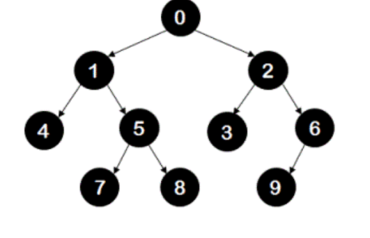
0 2 1 4 5 3 6 9 8 7

Struct Node
{
Int key;
Node* left;
Node* right;
};

Void print_tree(Node *root)
{
stack<Node*> even, odd;
even.push(root);
While (!even.empty() || !odd.empty())
{
If (!even.empty())
{
While (!even.empty())
{
Node* temp = even.top();
even.pop();
Cout << temp->key << “ “;
If (temp->left)
odd.push(temp->left);
If (temp->right)
odd.push(temp->right);
}

}
Else
{

}
}
}

Akljdefghi

Adcb -- bdca -> bacd

8
1 0
8 3 6 9
7 5 a
B
c

